Everything you need to know about Blue Light

By Catalina Calvera Maldonado

The global pandemic has brought along with it a lot of changes. Among them have been the work from home and remote learning approaches. There are many positives and negatives behind this change, such as reported increases in efficiency by some but lack of equipment and motivation by others. While everyone has been worried about Covid, we have forgotten about other important aspects of health: our eyes.

Multiple studies conducted before the pandemic showed that Blue Light exposure has several adverse health effects on both eyesight and skin. Now, as average screen time increases, so does exposure to blue light. Computer Vision Syndrome includes symptoms such as digital eye strain and blurry vision, headaches and neck/back pain. These are not only caused by blue light but by poor posture or lighting combined with other factors such as uncorrected vision problems.

What is Blue Light anyway?

In essence, blue wavelengths boost attention, reaction times and mood while suppressing the release of melatonin[1], all great things during daylight. The Sun is our main provider of blue light, which might suggest it isn’t all that harmful afterall, but as all things in nature, man has found a way to make it harmful. However, in a time when street lamps light up before sunset and the last thing we check before bed is our phones we are over exposed to blue light. This throws off our circadian rhythm - the internal process that regulates our sleep–wake cycle - which can lead to more concerning health issues. This is why we can’t have nice things...

In addition, as with cumulative sun exposure, recent studies show that the glare from screens can have an effect on the skin. Shari Marchbein, a professor of dermatology at NYU has stated that it "contributes to brown spots on the skin and hyperpigmentation such as melasma. Possibly to photoaging and the breakdown of collagen, which leads to wrinkles and skin laxity, too."[2]

We are not helpless however! Here are a few tips to keep healthy during remote working and learning:

* To help alleviate digital eye strain, the American Optometric Association recommends we follow the [20-20-20](https://www.aoa.org/AOA/Images/Patients/Eye%20Conditions/20-20-20-rule.pdf)[3] rule which consists in taking a 20 second break to take a look at something 20 feet away every 20 minutes of screen time.
* Not only have ‘Anti-Blue Light’ glasses become very fashionable lately but these verified special lens’ tints and coatings have been proven to heavily reduce the amounts of Blue light from LED and fluorescent lighting, monitors, tablets and mobile devices that reach the retina.
* We have probably all been recommended to limit our use of screen time 2-3h before bedtime, and it’s for good reason. Lose your phone, grab a book and wind down… we could all use a much needed break from social media. If you must use a device I encourage you to enable the night mode on your device and switch your lights to red and warmer toned shades at night, which are less likely to suppress melatonin and mess with your circadian rhythm[4].
* As the good weather approaches make sure to grab all those rays of sunshine during the day - if done outside make sure to follow covid regulations, wear a mask and maintain social distancing. Not only will the natural light boost your mood but help you work for that longed-for tan.
* To help alleviate back aches both a good posture and the computer screen’s location are key. Keeping at least 12 inches between the screen and your eyes and using ergonomic desks and chairs can play a huge role in posture issues. The image below shows what to avoid and encourages standing as our legs get tired from sitting all day too.

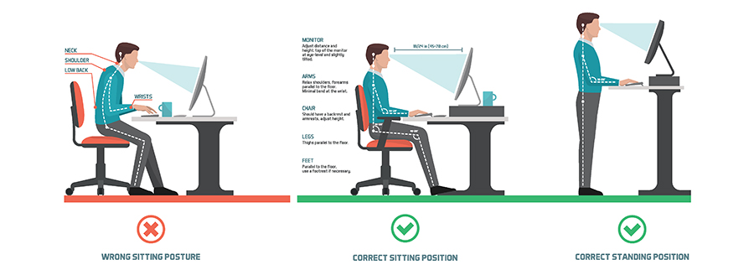

Bibliography:

“Computer Vision Syndrome (Digital Eye Strain).” *AOA.org*, [www.aoa.org/healthy-eyes/eye-and-vision-conditions/computer-vision-syndrome?sso=y](http://www.aoa.org/healthy-eyes/eye-and-vision-conditions/computer-vision-syndrome?sso=y)

Publishing, Harvard Health. “Blue Light Has a Dark Side.” *Harvard Health*, 7 July 2020, www.health.harvard.edu/staying-healthy/blue-light-has-a-dark-side.

Mackenzie, Macaela. “Here's What Blue Light From Phones Actually Does to Your Skin.” *Allure*, 14 July 2020, www.allure.com/story/blue-light-phone-skin-effects.

1. Harvard Health Publishing
2. Allure
3. American Optometric Association
4. Harvard Health Publishing